**Report I+II**

After the bandpass filter, notch filter and finally the derivative filter:

The SNR and Gain are then achieved in voltage ratio and power decible(consider residule as noise):

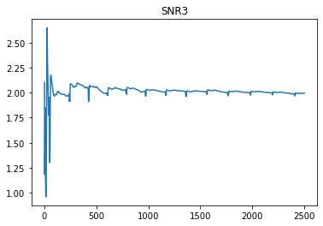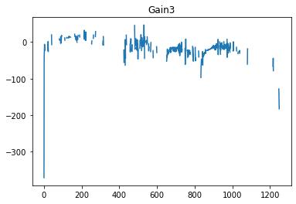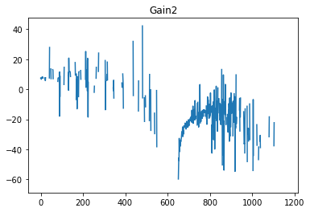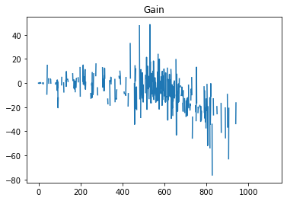

The residule is simply the absolute value of the difference of raw data and filtered data. AsI also will use energy collector, here the gains are also calculated on decible (log) level(dB) after the FFT with blackhamm window.  The smoothing process combined the minimization of the MSE of the smoothed data.

And through the simulation, the detection and classification of the QRS is as following(

The raw data is of 20 s 2500 samples in all, giving RRinterval:     RR = 20/13 (s),  nRR = int(np.round(n_ECG/12))= 208 samples fs = 1/20 , in bandpass filter: fc = 0.5(cut off frequency)

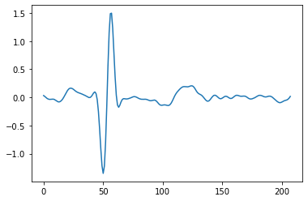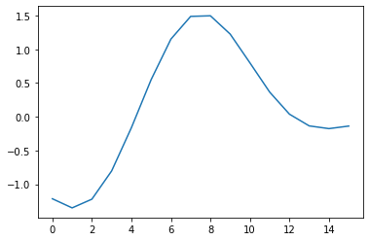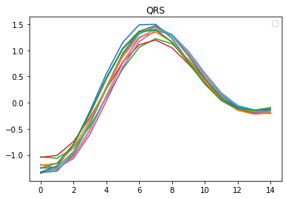

Finally the 13 QRS are all detected and averaged with in 15 sample coefficients windows. The process also add energy detector when there is only one crossing detected on voltage domain(setting low and high boundaries. While the crossing is detected, the value of the boundaries also changed dynamically. )

And the descriptive stachastics(of the QRS):

        Mean        SD        SE  95% Conf.  Interval

0   0.208398  0.917269  0.236838  -0.299568  0.716365

1   0.131324  0.897997  0.231862  -0.365970  0.628618

2   0.104734  0.770177  0.198859  -0.321776  0.531244

3   0.132274  0.742076  0.191603  -0.278674  0.543221

Markoc chain of CaMKII circuit with regards to cognitive systems diseases especially about the MC and GC networks around hippocampus and dendrate gyrus.

4   0.110860  0.890521  0.229932  -0.382294  0.604014

5   0.145349  0.929747  0.240060  -0.369528  0.660226

6   0.135127  0.905887  0.233899  -0.366536  0.636791

7   0.171742  0.895900  0.231320  -0.324391  0.667875

8   0.174389  0.875723  0.226111  -0.310570  0.659348

9   0.171013  0.911718  0.235404  -0.333880  0.675905

10  0.185101  0.872872  0.225375  -0.298280  0.668481

11  0.140275  0.839986  0.216883  -0.324893  0.605444

12  0.183746  0.852865  0.220209  -0.288555  0.656046

ANAVO test:

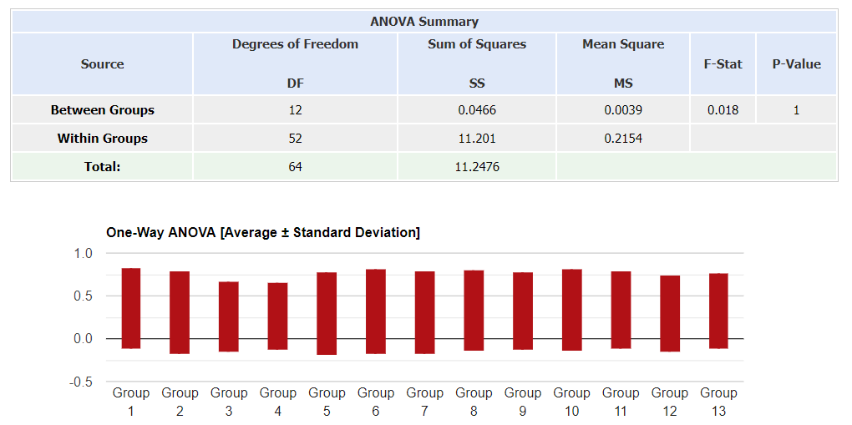

This is the clinical data on phisioNet and the this is the tracks of one 25 aged male person. (Multiple tracks).  Here the statistics are still about he 13 QRS. The data after the filter is smoothed although still a small moving trending is still remained. And the detected QRS of the stationized data follow the same distribution as shown in ECG and the p-value of the ANOVA test. The within group variation is rather high here as the data input into ANOVA is the statistics the 13 QRS and the mean square between groups in each factor is significantly smaller. As we only consider the ECG data only, the variation is really small which is also accordance with fast converged SNR. However, it is also not so satisfactory as the gain in all three filters are not changing significant and thus the filters behave not efficiently enough in enhancing the signal.

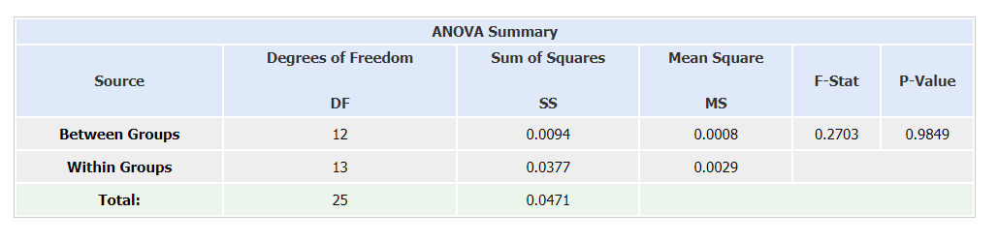

In the ECG signal reconstruction, I used the lead field method combining 4 nodes around source to reconstruct the result based on 1st Lead and achieve P while approximated with |J|*|Ji|/sigma/Ir*cos(alpha) and achieve Q. The optimization function is the log value of the sum of -KL and expectation of measurements given small data sets and parameter beta( the membrane parameter).

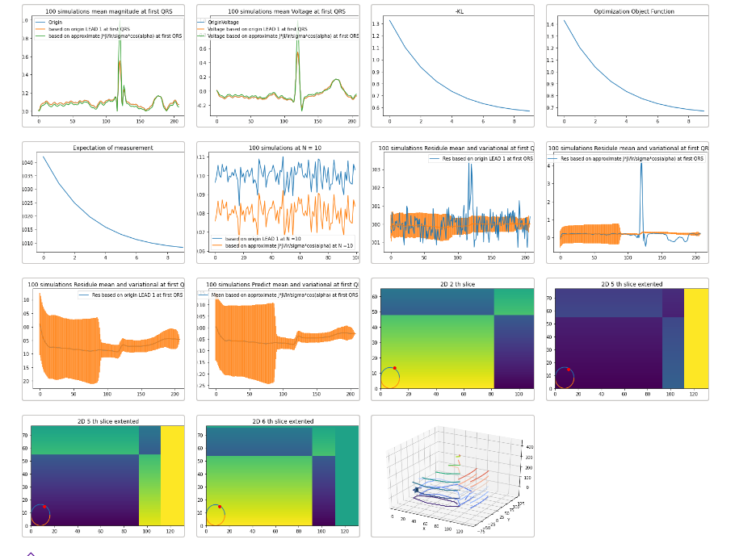

In the figures, the first image is the reconstruction of magnitude and the second is the reconstruction of voltage of ECG.(with sample points nRR: 208 ). On each sample, 100 simulations are conducted with MCMC minimizing the optimization function and which are the 3-5 images to achieve the magnitude (for instance the 10th on image 6). In the succeeded anaysis on the whole interval including Pwave QRS and Twave,  the error bar are also made with mean and CV of first reconstruction method and the mean and CV of second reconstruction method and their residule mean and CV (image 7-10).

Finally, the current prediction is also made on2D slice which is on the z0 plane of source.(I chose 11 slices in all and showed fouur of them in image 11-14).  And the final 3D(image 15) of the contour. Which is based on comparing the relative change of the voltage given current and its angle to the lead field.